Prudential TripleDES Encryption Installation Guide

Package

File List
- commons-lang-2.0.jar
- ibmjcefw.jar
- ibmjceprovider.jar
- ibmpkcs.jar
- ibmpkcs11.jar
- triple.jar
- sKey

Procedure

Java Runtime Update
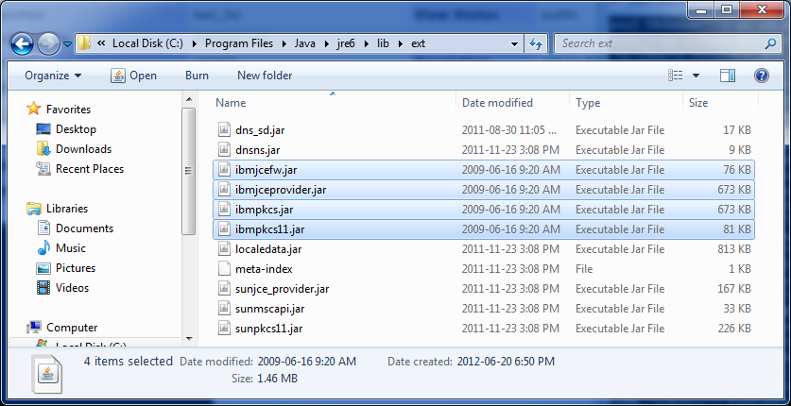
- Copy all “ibm*******.jar” to your JRE directory $JAVA_HOME/jre/lib/ext
E.g. C:\Program Files\Java\jre6\lib\ext
- Edit “java.security” in your JRE directory $JAVA_HOME/jre/lib/security
E.g. C:\Program Files\Java\jre6\lib\security
- To edit “java.security” in Windows 7 or Vista, you need to open editor with “Run as administrator”
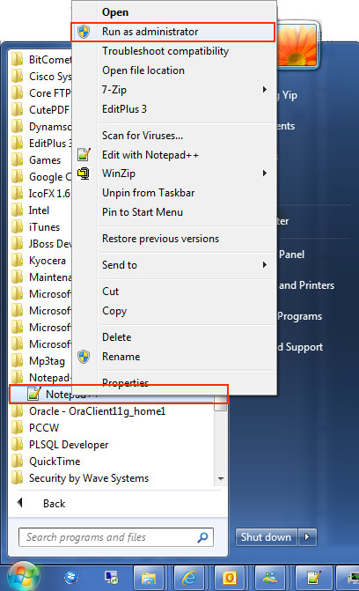
- Add line “security.provider.2=com.ibm.crypto.provider.IBMJCE” like below screenshot. Shift the sequence like 2 → 3 for original items
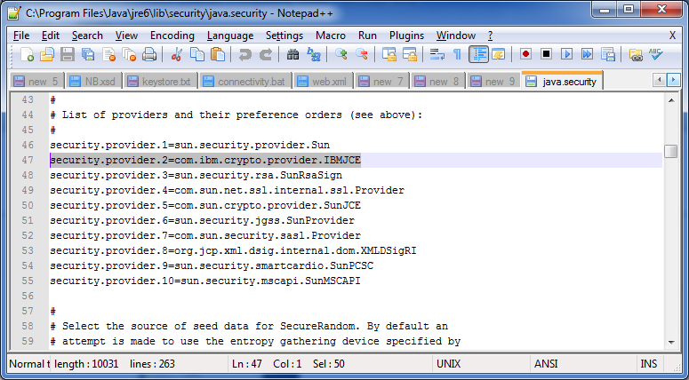

Use TripleDES in your Java Project
- Copy “sKey” to your JBoss Project directory $JBOSS_PROJECT/WEB-INF
- Copy “commons-lang-2.0.jar” to your JBoss Project directory $JBOSS_PROJECT/WEB-INF/lib
- Copy “triple.jar” to your JBoss Project directory $JBOSS_PROJECT/WEB-INF/lib
- TripleDES Function com.security.TripleDes.encryptPassword(userID, password)
- TripleDES testing URL http://192.168.222.48:8080/tripleDES/3des.jsp in SIT environment

